1. Employees Based on Employment Status
2. Employees Based on Education Level



Education Level M P Employee Count

1. Employees Based on Age Range

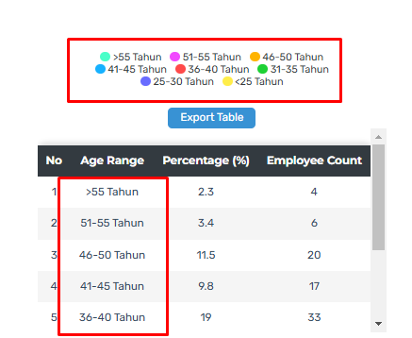

Tahun 🡪 Years

1. Employees Based on Length of Service Range

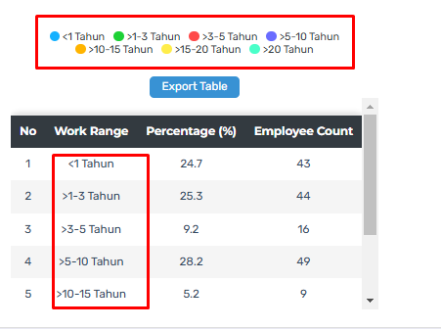

Tahun 🡪 Years

1. Employees Based on Work Unit

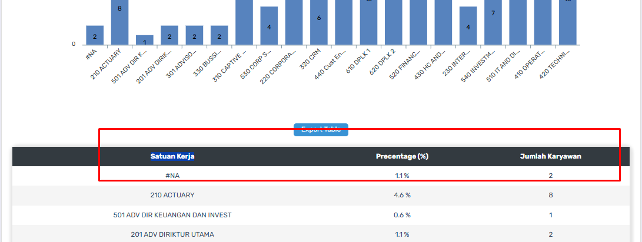

Work Unit Employee Count

1. Employees Based on Rank or Organization

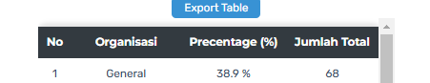

Organization Employee Count

1. Employees Based on Certification

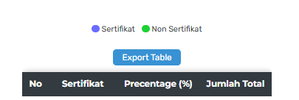

Certification Employee Count

1. Employee Certification Table



Employee Name Work Unit Certification Name

1. Employees Based on Turnover